Jing Mei Kindergarten Supply List 2017-2018

Communal Classroom Materials (please do not label)
1 - 8 ct. Crayola Washable Markers (classic colors or fine tip) 细彩色笔
1 - 8 ct. Crayola Washable Markers (classic colors, conical/broad tip) 粗彩色笔
1 – 8 ct. Expo Low Oder Dry Erase Markers (fine, black, blue, red and green) 可擦马克笔
1 – 12 ct. colored pencils 彩色铅笔
2 – 3 Ring Binder 1 inch 资料夹
8 - #2 Standard BIG pencils- sharpened, no sharpener 铅笔
1 – paper mate pink pearl eraser (medium size) 橡皮擦
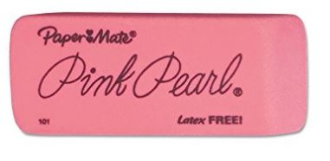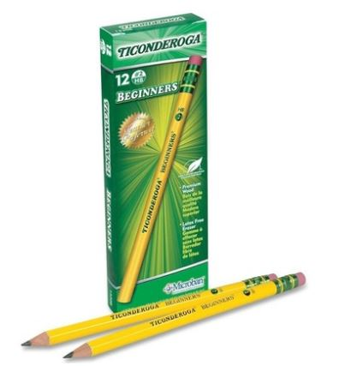
10 – Elmer’s small glue stick (washable, purple, dries clear) 胶棒
50 – sheet protectors (top loading, clear, thick kind) 纸张保护套
2 – box Ziploc slider storage bags (1 quarter and 1 galloon) 夹链袋
1 – box of unscented baby wipes 无味婴儿湿纸巾
1 – facial tissue 面纸
2 – plastic 2-pocket folder 文件夹
1 – pack of multi-color construction paper (legal size) 彩色手工纸
1 – 4x6 heavy weight index cards
1 hand sanitizer

